**Sheerah Arhanen** 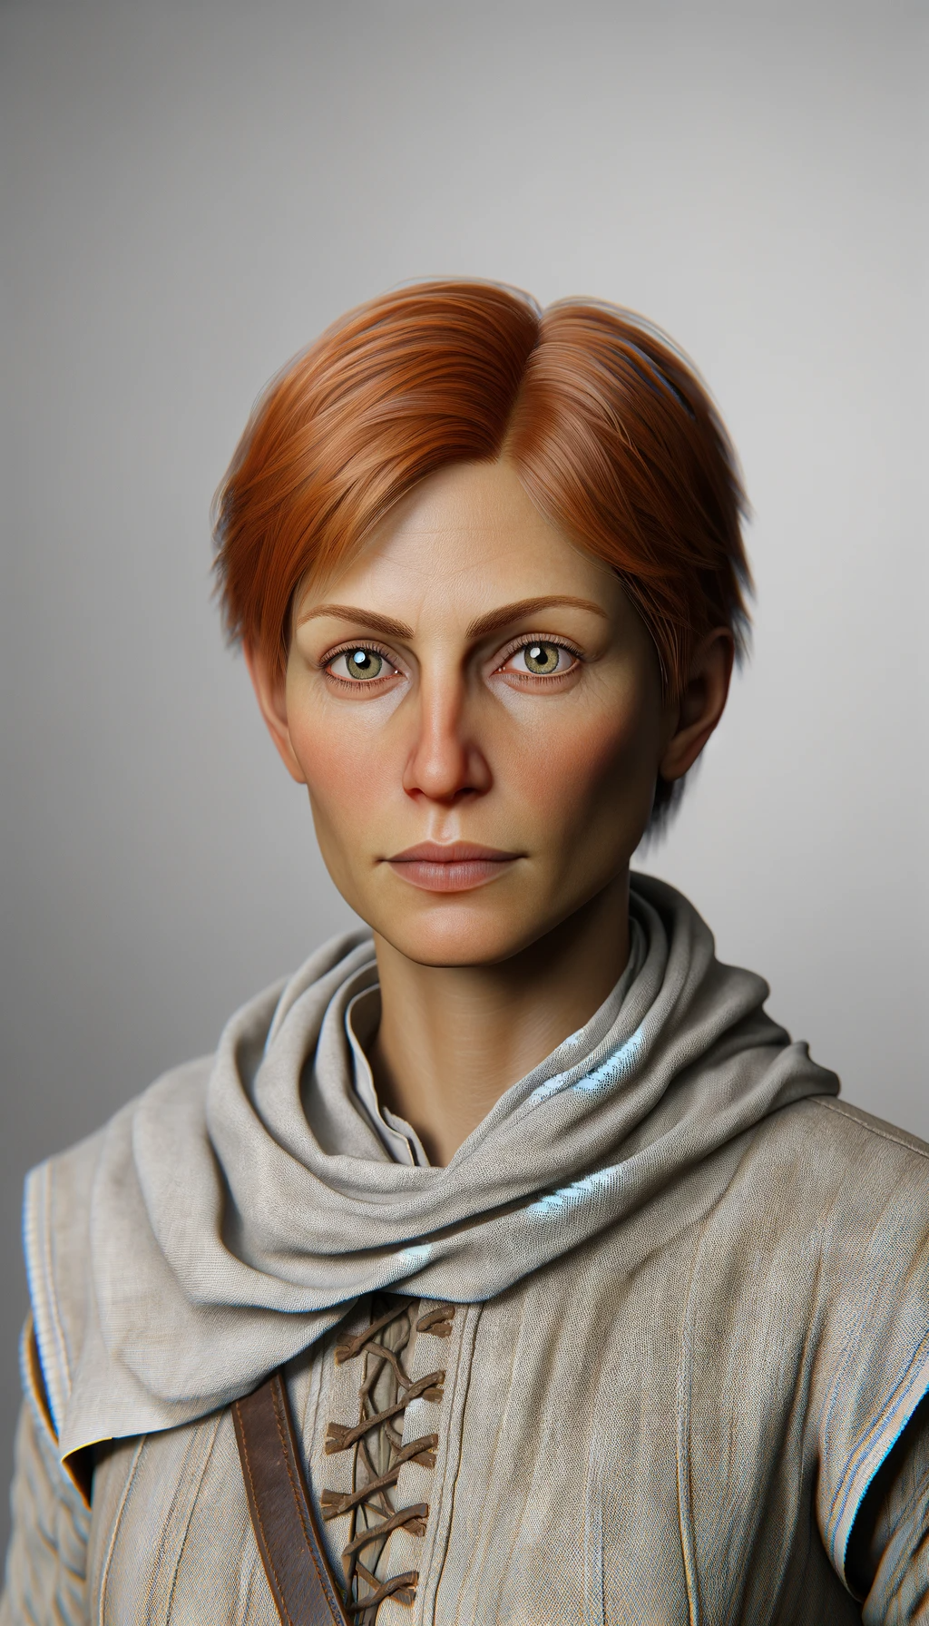

Teacher

**Rult Shune**

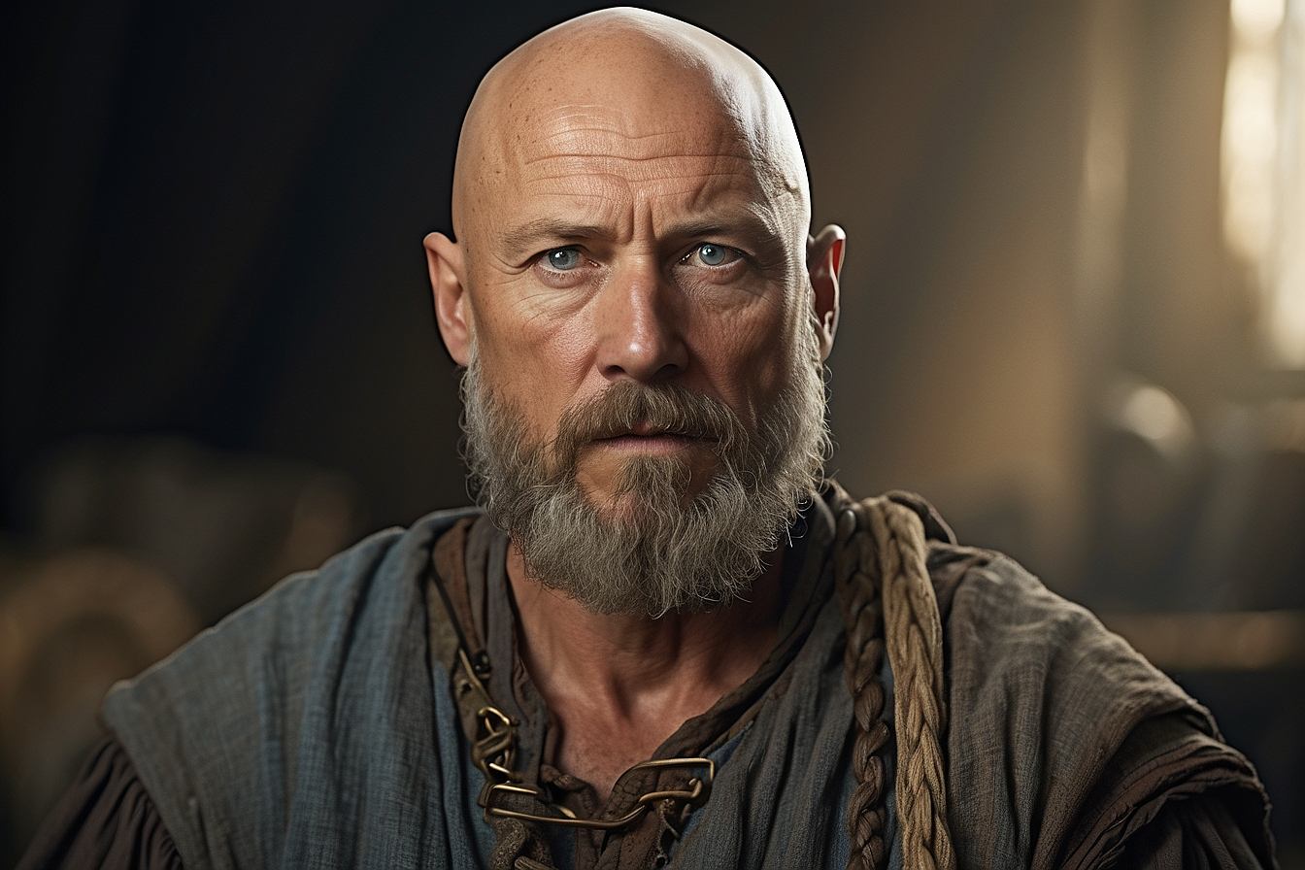

Labourer

**Rukhjan Qraatin**

Tavern owner

**Rorkar Amren**

Servant